**OMSB**

**Sultanate of Oman**

**Imtac LLC**

PO Box 196, PC 116, Mina-al-Fahal,

Muscat, Sultanate of Oman



Tables 1

Glossary 1

Team Members 2

1 Document Overview 3

1.1 Introduction 3

1.2 To Be Document 3

1.3 Target Audience 3

1.4 Actors in the module 4

1.5 Assumptions & Pre-requisites 5

2 BRD 5

2.1 Link to the BRD document 5

2.2 Additional BRD notes 5

3 Prototype 5

3.1 UX Link 5

4 ARS - Setup & Announcement of scholarship. 5

4.1 Objective of the module 5

4.2 Flow Diagram for setting up an ARS Setup 5

4.2.1 Screens 6

4.2.2 Business Logic 6

4.2.3 Notifications & Email template 11

5 Liferay Design Components 12

6 ER Diagram 13

7 Appendix A: Document Control 13

7.1 Revision History 13

Tables

Table 1: Glossary of terms 4

Table 2: Team members 4

Table 3: Target audience 5

Table 4: Description of actors 5

Glossary

|  |  |
| --- | --- |
| **Term** | **Description** |
|  |  |
|  |  |
|  |  |
|  |  |
|  |  |
|  |  |

Table 1: Glossary of terms

Team Members

|  |  |
| --- | --- |
| **Name** | **Role** |
| **Ravi Shah** | Tech Lead |
| **Jinal Patel** | Dev Lead |
| **Himanshu Nimavat** | Sr. Dev |
| **Niddhi Thacker** | Sr. Dev |
| **Taher Mahmood** | Sr. Dev |
| **Mathew** | Business Analyst |
| **Jayabalan T.** | Project Manager |
| **Hardik Vyas** | Project Manager |
| **Gaurav Gurjar** | Sr. UI Dev |
| **Siddhant Patel** | Sr. UI Dev |
| **Akash Nakod** | Sr. UX Designer |

Table 2: Team members

# Document Overview

## Introduction

The introduction of the Software Requirements Specification (SRS) provides an overview of the entire SRS with purpose, definitions, terms, abbreviations, and overview of the SRS. The aim of this document is to gather, analyse, and give an in-depth insight of the complete MSIC module by defining the problem statement in detail.

Nevertheless, it also concentrates on the capabilities required by stakeholders and their needs while defining high-level product features. The detailed requirements of the MSIC module is provided in this document.

## To Be Document

This Document is aimed to provide a detailed description of the To-Be system, and it will include several diagrams that show a different system aspect. The information of this document is based on the business requirement document that was created by Imtac and approved by the customer.

However, the result of the analysis and design process that is present in this document will enable the implementer to meet the exact customer requirements that appeared in previous document.

The solution requirements will be defined in enough detail to allow them to be constructed.

## Target Audience

|  |  |
| --- | --- |
| **Audience** | **Description** |
| **Technical Team** | This document aims to enable the technical team to understand the requirements to design and build the solution accordingly. |
| **Business Owner** | This document aims to enable the business owner to review the stated requirements as well as the required capabilities to be implemented. |
| **Quality Assurance** | This document aims to enable the QA to write the test cases related to the solution. |

Table 3: Target audience

## Actors in the module

|  |  |
| --- | --- |
| **Actor** | **Description** |
| **ARS Staff** | Do the initial setup of ARS programs. |
| **EC** | Create the panels for the interview. |
| **Media Department** | Create posts for announcement of the invitation of applications  for Program for each Academic Year |
| **Asst. Executive President for**  **International Cooperation** | Review and approve the announcement posts |

Table 4: Description of actors

## Assumptions & Pre-requisites

1. The Developer should follow sonar compliance when writing the code.
2. LDS should have sonar lint installed.
3. For each and every action, render, resource – a separate MVCCommands shall be implemented by the developer.
4. The default render generated by Liferay should not be used.
5. The naming conventions and the coding conventions shall be strictly followed by the Dev team as shared earlier.
6. The notification & email will be configurable using the email-configuration-template developed earlier.
7. RBAC – All the data-tables shall follow the RBAC framework of Liferay and it should be configurable.
8. All the language should go in Liferay’s Language Override module. (Strictly no language in properties file.)
9. Custom Form will be implemented along with jQuery validation.
10. Loader should be shown at all places. If the page load time is high and multiple service calls are happening on the page, better to show loader at render also. Also, for all the Ajax calls loader should appear. In case of cascading dropdowns also, loader should come. This is all for better user experience.
11. Headless approach will be used from coding perspective, so that in future if client demands the service to be consumed inside the mobile app, Web team will be able to make it available with minimal efforts.
12. Proper breadcrumbs should be implemented as per our MSIC flow.
13. Relevant data to be inserted while testing on any servers.
14. The service builder generated entities must have a namespace appended i.e., OMSB_AD.
15. The audit fields should be present for all the database tables.
16. Proper loggers should be used to log the information. Also, wherever needed their only use log.info else put it “log.debug”.

# BRD

## Link to the BRD document

## Additional BRD notes

NA

# Prototype

## UX Link

# ARS - Setup & Announcement of scholarship.

## Objective of the module

The objective of the module is to set up scholarships for different programs, allowing ARS users to create setup and mark the necessary configuration each year based on their requirements. After the announcement of these configurations, the EC can create a panel and suggest members. The ARS user will then add the actual members to the interview panel. This process aims to completely set up the program each year according to the configurations or requirements of OMSB.

## Flow Diagram for setting up an ARS Setup

|  |  |  |
| --- | --- | --- |
| **Step #** | **User** | **Action Taken** |
| 1 | ARS User | The ARS user will create a program configuration based on the program type and other fields, and they can also delete and update the program configuration. |
| 2 | ARS User | Based on the program configuration, the ARS user will create the admission configuration for a specific year, and they can also update and delete the admission configuration. |
| 3 | ARS User | The ARS user will initiate the media request to announce the admission configuration. |
| 4 | Media Department | Submit the program announcement. |
| 5 | Asst. Executive President for  International Cooperation | Reviews the announcement and approves it. |
| 6 | EC User | The EC user will create a panel and add the suggested members for the announced program for the current year. |
| 7 | ARS User | The ARS user will be notified of the created panel and will add the actual members to the panel. |
| 8 | ARS User | The ARS user will add the employer as an employment representative. |

### **Screens**

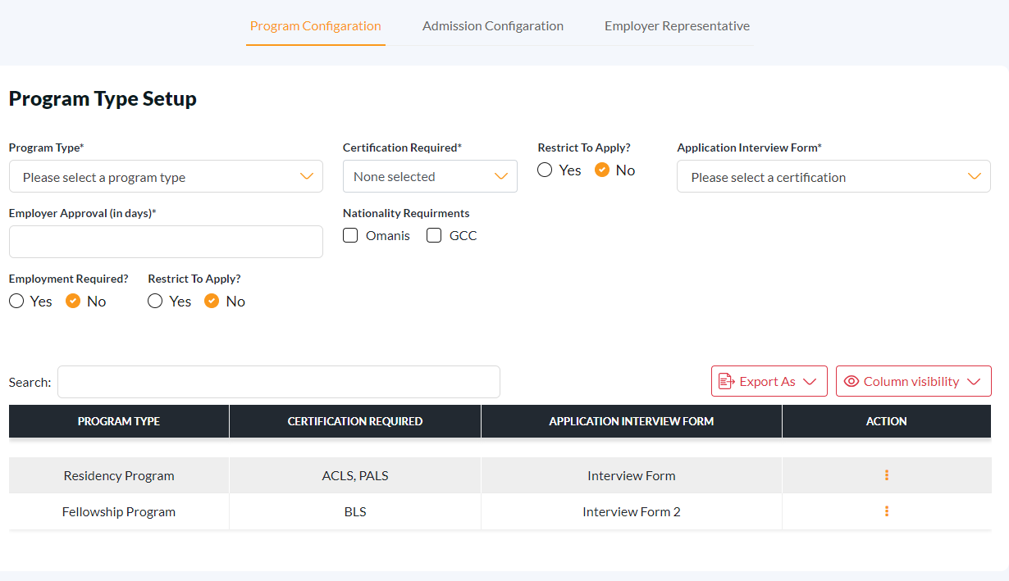

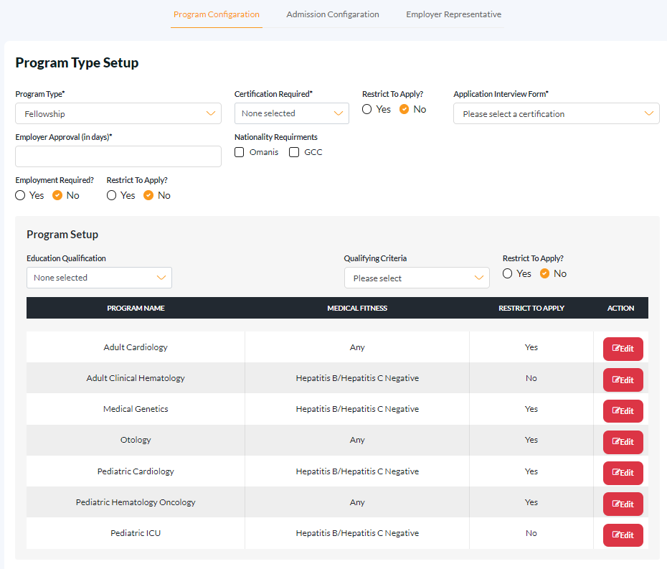

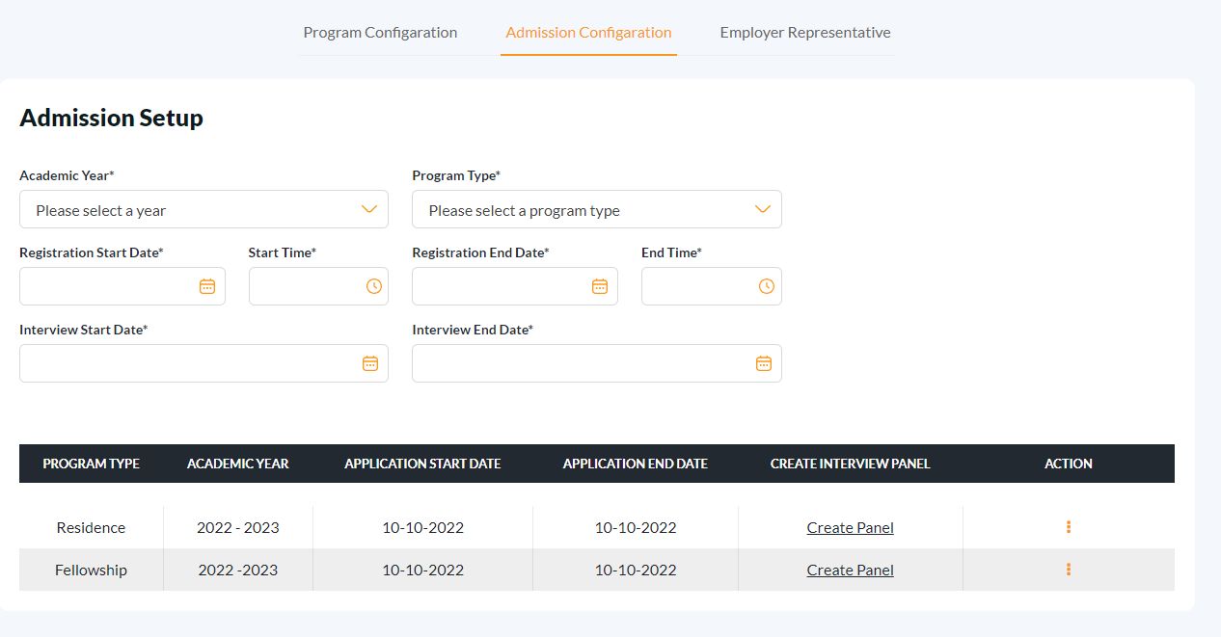

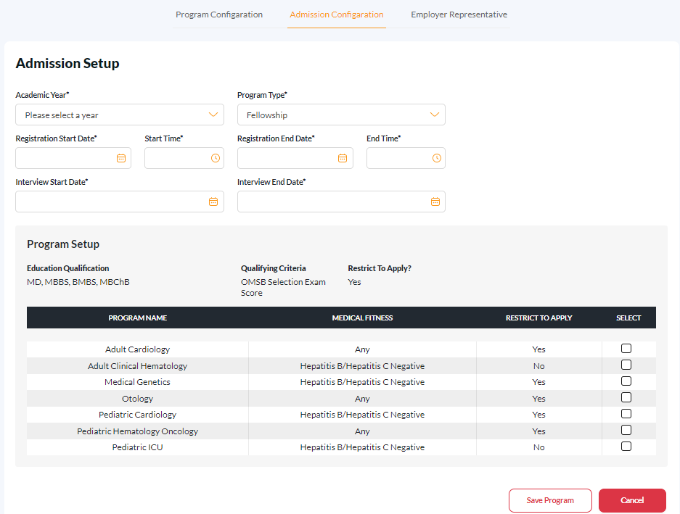

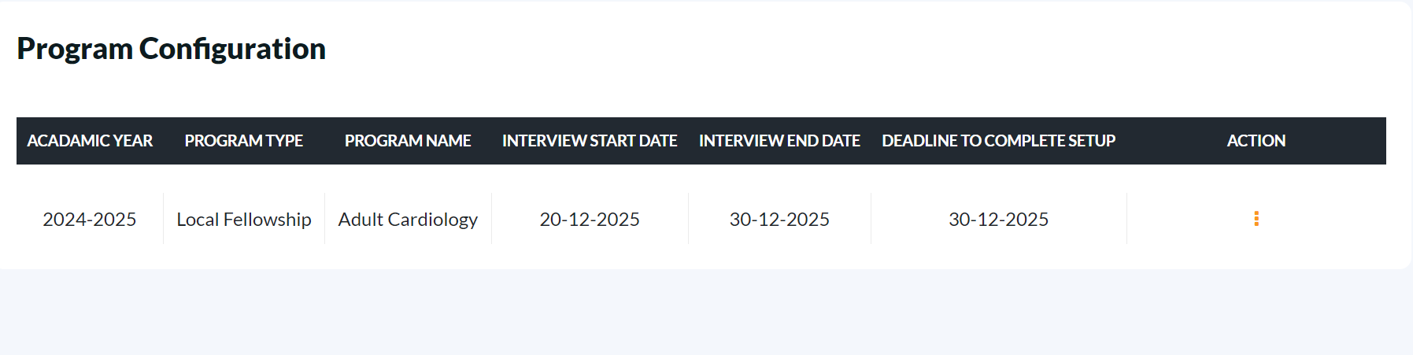

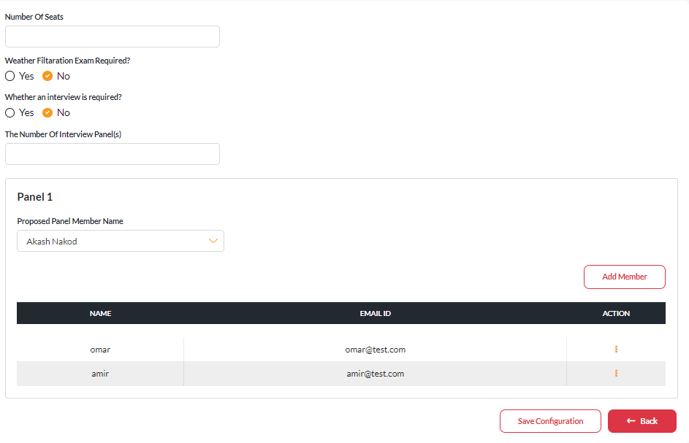

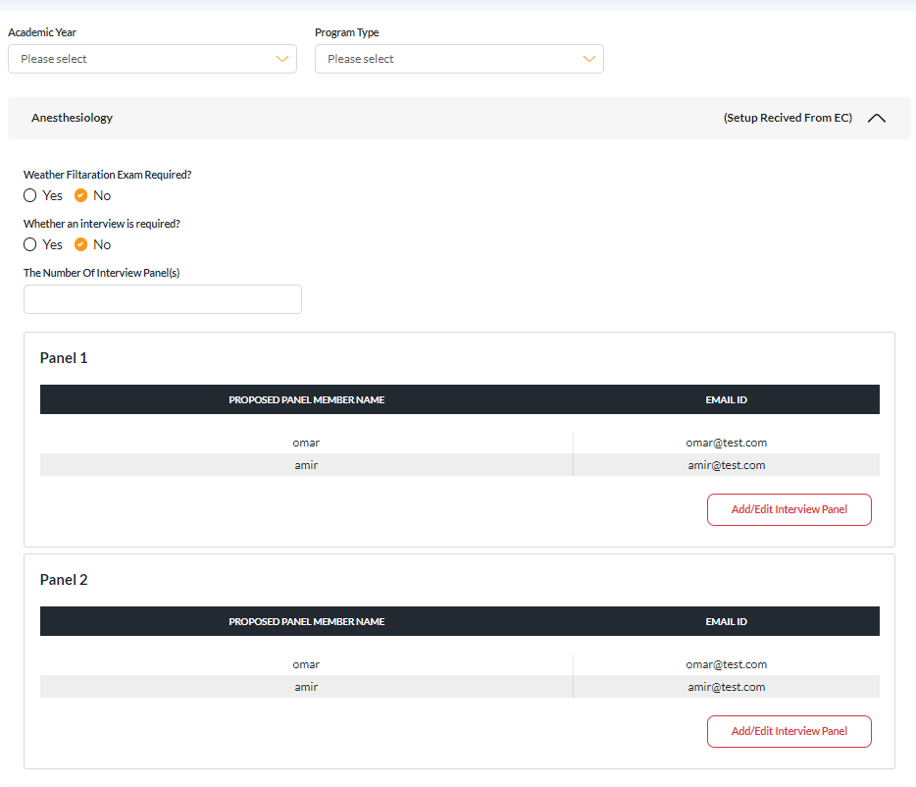

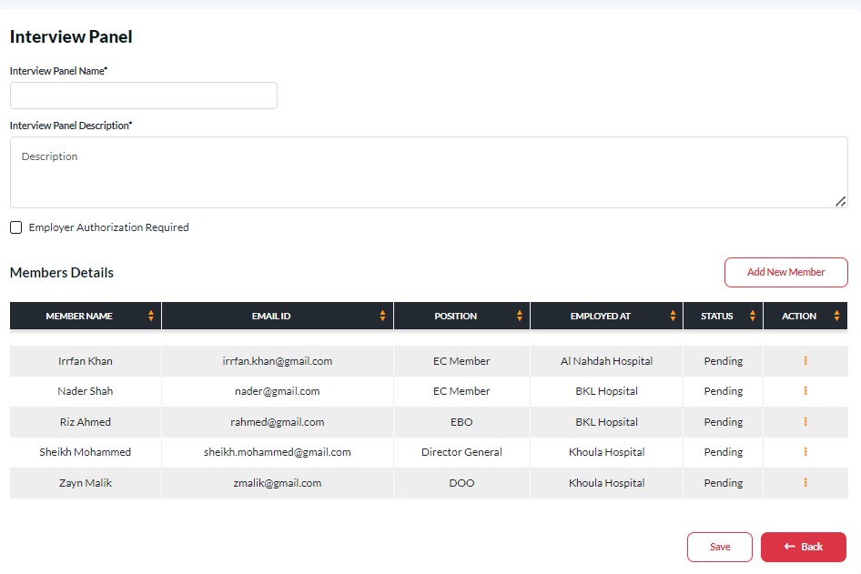

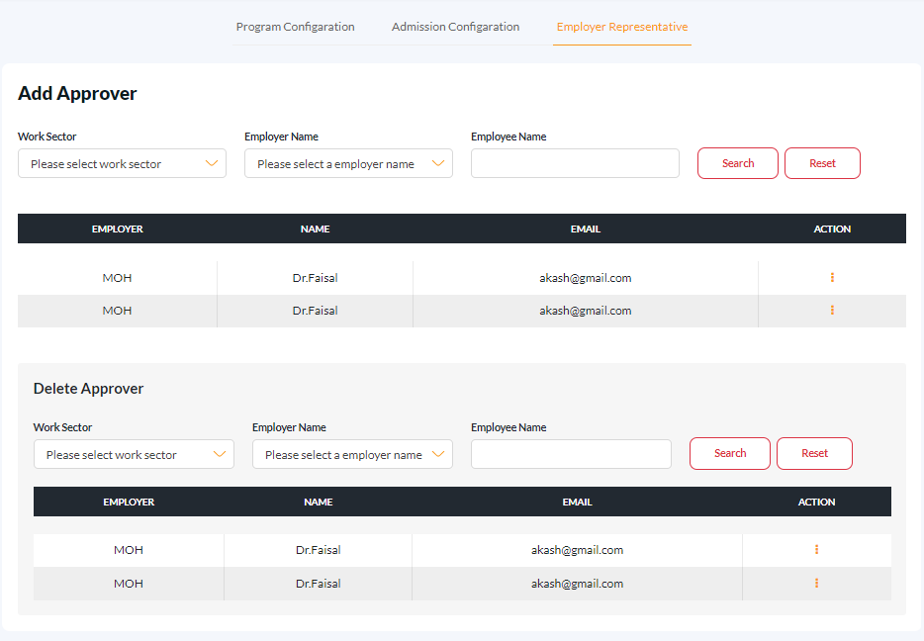

### **Business Logic**

1. The ARS User will login to the e-portal. Once login, they should be able to see following navigation menus on the LHS.
   1. Admission Setup
2. When clicked on Admission Setup, they will land on Admission Setup screen.
3. The ARS User will select the program type if that is not added earlier otherwise, he will edit the program type and change the configuration and save it.

|  |  |  |  |  |
| --- | --- | --- | --- | --- |
| Field Name | Mandatory/Optional | Field Type | Multilingual Support | Comments |
| Program Type | Mandatory | Drop down | No |  |
| Certification Required | Mandatory | Multiple Checkbox | No |  |
| Restrict to Apply | Mandatory | Boolean | No | This restrict to apply for certificate field. |
| Application Interview Form | Mandatory | Drop down | No |  |
| Employer Approval (in days) | Mandatory | numeric | No |  |
| Nationality Requirements | Optional | Multiple Checkbox | No |  |
| Employment Required? | Mandatory | Boolean | No |  |
| Restrict to Apply | Mandatory | Boolean | No | This Restrict to apply for employment Required field. |
| Approval From Employer Required? | Mandatory | Boolean | No |  |
| Setup Program For | Optional | Multiple Checkbox | **No** |  |
| Education Qualification | Optional | Multiple Checkbox | **No** |  |
| Qualifying Criteria | Mandatory | Drop down | **No** |  |
| Restrict To Apply | Mandatory | Boolean | No | This Restrict to apply for Qualifying criteria field. |
| Medical Fitness | Mandatory | Drop down | **No** |  |
| Restrict to Apply | Mandatory | Boolean | No | This Restrict to apply for Medical Fitness field |

1. Once the program is created, they cannot create a new program configuration for the same program type.
2. They can either edit the existing program type or delete it. However, if this program configuration is associated with an admission configuration, they cannot delete the program configuration until the admission configuration is deleted.
3. In the admission configuration, they can see which program types have been created in the program configuration.
4. The ARS User will select the program type for the specific year in the admission configuration.
5. Based on the program type, all the configured fields should auto-populate in the admission configuration, and they can select the program for the selected year and save it.

|  |  |  |  |  |
| --- | --- | --- | --- | --- |
| Field Name | Mandatory/Optional | Field Type | Multilingual Support | Comments |
| Academic Year | Mandatory | Drop down | No |  |
| Program Type | Mandatory | Drop down | No |  |
| Registration Start Date | Mandatory | Date | No |  |
| Start Time | Mandatory | Time | No |  |
| Registration End Date | Mandatory | Date | No |  |
| End Time | Mandatory | Time | No |  |
| Interview Start Date | Mandatory | Date | No |  |
| Interview End Date | Mandatory | Date | No |  |
| Setup Program For | Optional | Multiple Checkbox | No |  |
| OMSB Selection Exam Cutoff Score | Optional | numeric | No |  |
| Programs | Optional | Multiple Checkbox | No |  |

1. The ARS User cannot create a new admission configuration for the same year and program type. If they wish, they can edit the created record or delete it. Once the announcement is made, they cannot delete the admission configuration.
2. After creating the admission configuration for the program type, the ARS User will request the media announcement.
3. The media user will then submit the related documents.
4. The AEP user will approve or reject the media request.
5. After the media announcement, the EC User will log in to the e-portal. Once logged in, they should be able to see the following navigation menus on the LHS:

b. Interview Panel

1. The EC can see only their related programs. After that, they will create the panel for the specific program type, then add the suggested members to the interview panel.

|  |  |  |  |  |
| --- | --- | --- | --- | --- |
| Field Name | Mandatory/Optional | Field Type | Multilingual Support | Comments |
| Filtration Exam Required | Mandatory | Boolean | No |  |
| Interview is required | Mandatory | Boolean | No |  |
| Number Of Interview Panels | Optional | numeric | No |  |
| Proposed Panel Member Name | Mandatory | Text box | No |  |
| Email Id | Mandatory | Text box | No |  |

1. The ARS User will be notified of the EC-created panels for the programs and will add the panel name and actual members to the interview panel by searching for their names. If a user is not found, the ARS user can send an invitation.

|  |  |  |  |  |
| --- | --- | --- | --- | --- |
| Field Name | Mandatory/Optional | Field Type | Multilingual Support | Comments |
| Interview Panel Name | Mandatory | Text box | No |  |
| Interview Panel Description | Mandatory | Text box | No |  |
| Employer Authorization Required | Mandatory | Boolean | No |  |

1. While adding panel details, if the user checks 'Employment Authorization Required,' then when adding a member, the member's status should be set to pending.
2. The ARS user or employer representative can approve, reject, or set a member as chairman.
3. The ARS user will add the employer as an employment representative by searching below fields.

|  |  |  |  |  |
| --- | --- | --- | --- | --- |
| Field Name | Mandatory/Optional | Field Type | Multilingual Support | Comments |
| Primary Workplace Sector Type | Mandatory | Drop down | No |  |
| Primary Sector Name | Mandatory | Drop down | No |  |
| Please Specify (Sub Sector) | Optional | Drop down | No |  |
| Governorate of Primary Institution | Optional | Drop down | No |  |
| Employee Name | Optional | Text Box | No |  |

1. They can also delete the added employer from the employment representatives.

### Notifications & Email template

The following email and notification content should be used when sending emails & notifications

|  |  |  |  |  |
| --- | --- | --- | --- | --- |
| **Scenario** | **Notification** | **Notification Action** | **Email** | **Email Action** |
| **When ARS User requests for the Media Announcement by clicking on the submit button of request Media Announcement page.** | Greetings [$REQUESTER_NAME$], ARS User Announced [$PROGRAM_NAME$] program for [$YEAR$] academic year. | When clicked on notification The EC User will be redirected to program configuration page. | Dear [$REQUESTER_NAME$],  ARS User Announced [$PROGRAM_NAME$] program for [$YEAR$] academic. Click here to create the panel.  Best Regards,  Oman Medical Speciality Board. | When clicked on email link The EC User will be redirected to program configuration page. |
| **When EC user creating the panel by clicking on the save configuration button in program configuration page.** | Greetings [$REQUESTER_NAME$], EC has created a panel for the [$PROGRAM_NAME$] Program for the [$YEAR$] academic year. | When clicked on notification The ARS user will be redirected to creating panel details page. | Dear [$REQUESTER_NAME$],  EC has created a panel for the [$PROGRAM_NAME$] Program for the [$YEAR$] academic year. Click here to view the panel.  Best Regards,  Oman Medical Speciality Board. | When clicked on email link The ARS User will be redirected to creating panel details page. |
| **When the ARS user searches for a user to add to the interview panel or to add as an employer representative but cannot find the user, if they can click the invite button.** | N/A | N/A | Dear [$REQUESTER_NAME$],  Kindly register on the OMSB e-Portal by clicking the link below. click here.  Best Regards,  Oman Medical Speciality Board. | When clicked on email link The User will be redirected to E-portal. |
| **When the ARS user adds a user as an employer representative by clicking the 'Add Approver of Employer' button in the employer representative tab.** | Greetings [$REQUESTER_NAME$], We are pleased to inform you that you have been added to the employer approver list. | N/A | Dear [$REQUESTER_NAME$],  We are pleased to inform you that you have been added to the employer approver list. Click here.  Best Regards,  Oman Medical Speciality Board. | N/A |

# Liferay Design Components

|  |  |  |  |
| --- | --- | --- | --- |
| **Liferay Page Name** |  | **Page Type** | Private |
|  |
| **Layout Name** | Custom: 1 Column | **Layout Type** | 100 |
|  |  |  |  |
|  | omsb-common-api | The API module will be responsible for creating contracts(interfaces) that will be used across all the web modules to access the APIs’. All the model classes responsible for request & response of the Http Connections should reside in this module. The common constants too should be part of this module. | |
| omsb-common-service | The service module will be responsible for implementing the contracts that are defined in the omsb-common-api | |
|  | omsb-admission | Service builder for ARS Setup Module. All the tables should be prefixed with namespace as “ars” | |
|  | omsb-form-builder | This module should be included to take the advantage of existing form builder module | |
|  | omsb-media-appeal | Service builder for Media Files request as this will be used at many places. All the tables should be prefixed with namespace as “ma” | |
|  | omsb-ars-program-setup-web | This module contains the code for setting up the scholarship for programs. | |
| **Java Script Plugin Details** | JavaScript/jQuery | Used for implementing the dynamic generation of the html elements | |

# ER Diagram

[[Database-Design.xlsx](https://imtac.sharepoint.com/:x:/r/sites/omsb-aims/Shared%20Documents/1.OMSB%20Engineering/3-Development/Phase-2/Design/MSIC/Database-Design.xlsx?d=wb9758adc7c3d4fb284fb65bcad263f8d&csf=1&web=1&e=bM5Hgv)](https://imtac.sharepoint.com/:x:/r/sites/omsb-aims/_layouts/15/Doc.aspx?sourcedoc=%7B51F6197A-2144-4BE9-9F69-32ACB4B32456%7D&file=Database%20Design(ARS%20&%20SAS).xlsx=&action=default&mobileredirect=true)

# Appendix A: Document Control

## Revision History

|  |  |  |  |
| --- | --- | --- | --- |
| **Version** | **Date** | **Amended By** | **Reason for Change** |
| **1.0** | 08/11/2023 | Ravi Shah | Initial Draft |

Table 7: Revision History